Rossmoyne SHS | Semester 2/ Trial WACE Examination, 2011 | 

NAME: _____Marking Guide____________________________________

Question/Answer Booklet

MATHEMATICS 2C/2D
Teacher: Circle One

Belonogoff Fletcher Longley Pui Tanday Tay

Section Two:

Calculator-assumed

Time allowed for this section
Reading time before commencing work: ten minutes
Working time for this section: one hundred minutes

Materials required/recommended for this section

To be provided by the supervisor
This Question/Answer Booklet
Formula Sheet (retained from Section One)

To be provided by the candidate
Standard items: pens, pencils, pencil sharpener, eraser, correction fluid/tape, ruler, highlighters

Special items: drawing instruments, templates, notes on two unfolded sheets of A4 paper, and up to three calculators satisfying the conditions set by the Curriculum Council for this examination.

Important note to candidates

No other items may be used in this section of the examination. It is your responsibility to ensure that you do not have any unauthorised notes or other items of a non-personal nature in the examination room. If you have any unauthorised material with you, hand it to the supervisor before reading any further.

Structure of this paper

Section | Number of questions available | Number of questions to be answered | Working time (minutes) | Marks available | Percentage of exam
Section One:  Calculator-free | 6 | 6 | 50 | 40 | 33
Section Two:  Calculator-assumed | 11 | 11 | 100 | 80 | 67
 |  |  | Total | 120 | 100

Instructions to candidates

- The rules for the conduct of Western Australian external examinations are detailed in the Year 12 Information Handbook 2011. Sitting this examination implies that you agree to abide by these rules.

- Write your answers in the spaces provided in this Question/Answer Booklet. Spare pages are included at the end of this booklet. They can be used for planning your responses and/or as additional space if required to continue an answer.
- Planning: If you use the spare pages for planning, indicate this clearly at the top of the page.
- Continuing an answer: If you need to use the space to continue an answer, indicate in the original answer space where the answer is continued, i.e. give the page number. Fill in the number of the question(s) that you are continuing to answer at the top of the page.

- Show all your working clearly. Your working should be in sufficient detail to allow your answers to be checked readily and for marks to be awarded for reasoning. Incorrect answers given without supporting reasoning cannot be allocated any marks. For any question or part question worth more than two marks, valid working or justification is required to receive full marks. If you repeat an answer to any question, ensure that you cancel the answer you do not wish to have marked.

- It is recommended that you do not use pencil, except in diagrams.

Section Two: Calculator-assumed (80 Marks)
This section has eleven (11) questions. Answer all questions. Write your answers in the spaces provided.

Working time for this section is 100 minutes.

Question 7 (6 marks)
A student exercises on Monday, Tuesday and Wednesday each week. On the Monday, they always choose between cycling, running or swimming. They also choose one of these three types of exercise on the other two days, except that they never do the same type of exercise on two consecutive days and they always follow a running day with a swimming day.

(a) Draw a tree diagram to show the possible choices of exercise for the three days.
(2 marks)
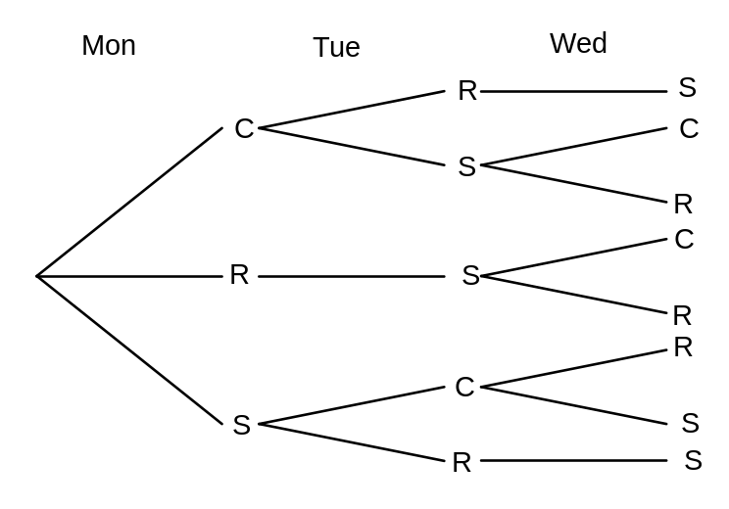

 2 0r 1 or o marks

(b) If each outcome in the sample space is equally likely, what is the probability that the student

(i) swims on Wednesday? (1 mark)
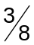

(ii) does not run at all during the three days? (1 mark)
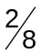

(iii) swims on one day and then cycles on the next? (1 mark)
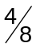

(iv) runs on two days, given that they run at least once? (1 mark)
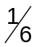

Question 8 (10 marks)
A student went for a run every morning during the month of June along a variety of routes. The time taken for each run was recorded to the nearest minute and the data is shown below, after the times have been sorted from shortest to longest.

17, 18, 19, 20, 21, 21, 22, 23, 23, 24, 24, 25, 25, 25, 25,
26, 26, 26, 27, 27, 27, 28, 30, 30, 30, 31, 33, 33, 34, 35.

The mean of these 30 times is 25.8 minutes and the standard deviation is 4.6 minutes.

(a) For the times recorded in June, what is

(i) the mode? (1 mark)

25 minutes

(ii) the median? (1 mark)
25.5 minutes

(iii) the range? (1 mark)

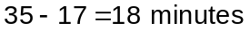

(b) Use the above data to complete this frequency table. (1 mark)

Run time (minutes) | Number of days
16 - 18 | 2
19 - 21 | 4
22 - 24 | 5
25 - 27 | 10
28 - 30 | 4
31 - 33 | 3
34 - 36 | 2
 R/W
The following month the student continued their morning runs. The 31 times for July are shown in the table below.

Run time (minutes) | Number of days
13 - 15 | 4
16 - 18 | 4
19 - 21 | 3
22 - 24 | 7
25 - 27 | 8
28 - 30 | 3
31 - 33 | 2

(c) For the times recorded in July, what is

(i) the range? (1 mark)
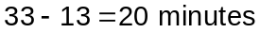

(ii) the mean and standard deviation? (2 marks)

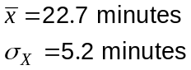


(f) Which of the range or standard deviation is the more suitable measure to rank the data for June and July in order of spread? Explain your answer and state in which month the data was more spread. (3 marks)

The standard deviation is more suitable. 

It represents the average spread of all the times, rather than just the difference between two of the times – the minimum and maximum. 
The July times were more spread as 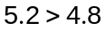.

Question 9 (8 marks)
Amy borrowed $1570 to buy a scooter with a purchase price of $1793.

(a) What percentage of the purchase price did Amy borrow, correct to 3 significant figures?
(2 marks)
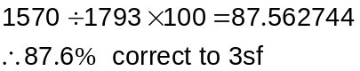


(b) The loan company charged interest of 14% of the amount borrowed. If Amy repaid the loan and interest in 6 equal amounts, how much was each repayment? (2 marks)

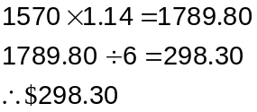


(c) Amy expects her scooter to depreciate in value by 15% per year.

(i) What will its value be after one year, to the nearest ten dollars? (2 marks)
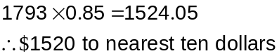


(ii) After how many years will the value of the scooter first be less than $1000?
(1 mark)
After 4 years (~$940) 

(d) The purchase price included GST at 10%. How much GST was included in the purchase price? (1 mark)
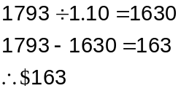

Question 10 (5 marks)
A manufacturing company produces several different triangular gusset plates to use in reinforcing structures which they build. Two of the triangular gusset plates are shown below, not drawn to scale, and both have the same area. All lengths shown are in millimetres.

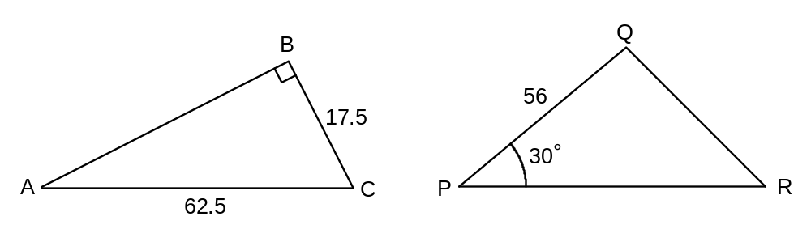

(a) Determine the area of triangle ABC. (3 marks)

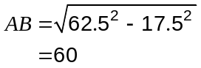

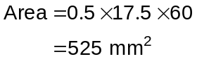


(b) Find the length of side PR. (2 marks)
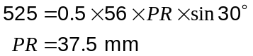


Question 11 (10 marks)
The results of a traffic flow survey at a T-junction (see diagram) between 7.00 am and 9.00 am one weekday morning are shown in the table below.

 |  | To
 |  | A | B | C | 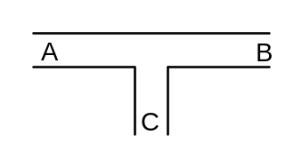
From | A | 0 | 435 | 86 | 521
From | B | 312 | 0 | 161 | 473
From | C | 62 | 210 | 0 | 272
 |  | 374 | 645 | 247 | 1266

For example, of the 521 vehicles which arrived at the junction from A, 435 went straight on to B and the other 86 made a right turn towards C.

(a) Where are the majority of vehicles going to after leaving the junction? (1 mark)

Towards B 

(b) Calculate the relative frequency of vehicles which arrived at the junction from C. (2 marks)

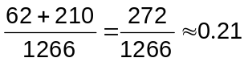

(c) In a random sample of 200 vehicles from the survey, it was found that 31 had made a left turn on arriving at the junction. Is this number within the range of values that you would expect? Justify your answer. (4 marks)

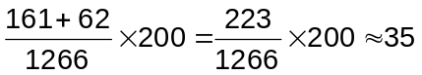

31 is close to the expected value of 35
and so is a likely outcome of the random
sample. 

Some engineers were planning how to model traffic flow of vehicles arriving at the junction from C over a weekend, at which time they estimated that 37% made a left turn towards A and the rest made a right turn towards B.

(d) Explain how the engineers could use the list of random numbers, such as the one below, to simulate whether a vehicle coming from C makes a left or right turn at the junction.
(2 marks)
79 61 32 44 81 56 69 02 68 72 41 39 01 04 38

Take the digits two at a time, to represent numbers from 0 to 99. If the number is less than 37 then a left turn is made, otherwise a right turn. 

(e) Use your simulation method and the random numbers in (c) to determine how many of the first ten vehicles arriving at the junction made a left turn. (1 mark)
R R L R R R R L R R. Hence 2 turned left. 

Question 12 (6 marks)
(a) Draw a neat sketch of the function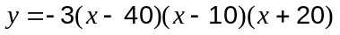, indicating all axes intercepts. 3 or 2 or 1 or 0 mark (3 marks)
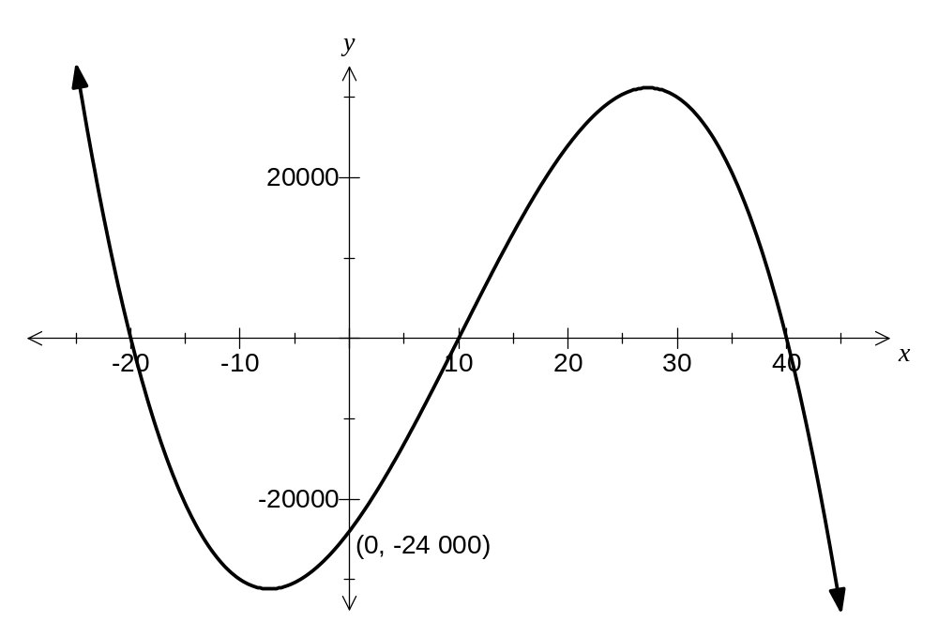

(b)
(i) Draw a neat sketch of the function 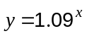 2 or 1 or 0 mark (2 marks)
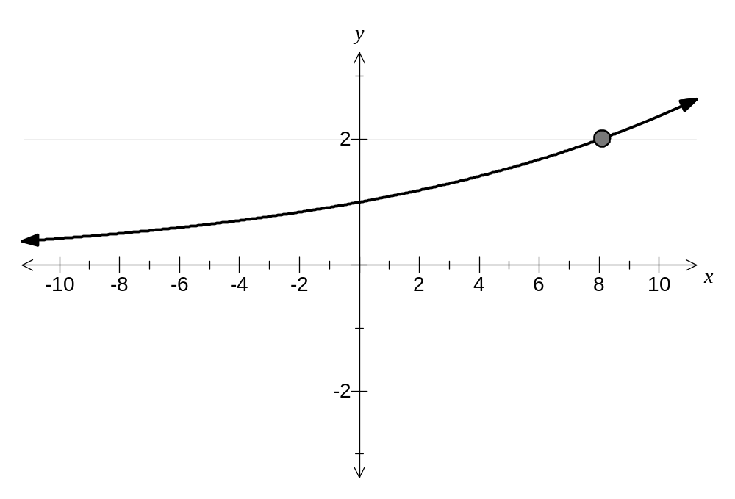
(ii) Show on your sketch where the solution to 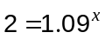 can be found.  (1 mark)

Question 13 (8 marks)
(a) The first two terms of a geometric sequence are 20 and 16 respectively.

(i) Write a recursive rule for this sequence. (2 marks)
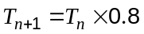  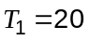

(ii) Find the largest term of this sequence which is less than 5. (1 mark)

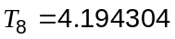

(b) The recursive formula 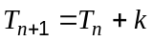 was used to generate the sequence with 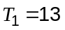 and 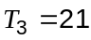.

(i) State the value of . (1 mark)
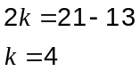

(ii) Is the statement "all arithmetic sequences with a positive difference will always consist only of positive numbers" true? Explain your answer. (2 marks)

No. 
For example, consider the arithmetic sequence -5, -3, -1, 1, 3 which has both a positive difference and a negative number as a term. 

(c) Write down the equation of the straight line passing through the two points A(1, 13) and B(3, 21).
(2 marks)
Note link to sequence in (b)(i) with 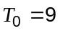

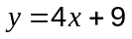

Question 14 (8 marks)
A road passing through town T located at the origin, follows a path given by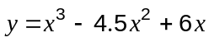, where the x-coordinate is the distance east of T and the y-coordinate is the distance north of T, in kilometres.

(a) Draw the graph of on the axes below. 3/2/1/0m (3 marks)
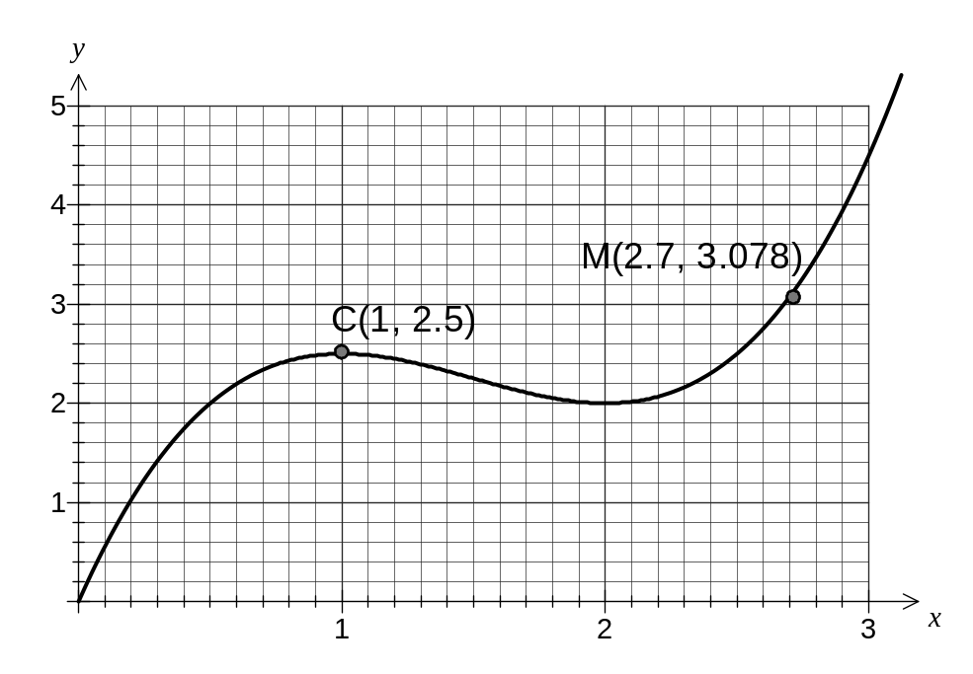

(b) Mark on your graph the position and coordinates of a car C, that is on the road at a point 1 km east of T.  (1 mark)

(c) Mark on your graph the position and coordinates of a motorbike M, that is on the road at a point 3.078 km north of T.  (1 mark)

(d) A short time later the car is at A(1.3, 2.392) and the motorbike is at B(2.9, 3.944). Calculate the straight line distance, in kilometres, between the car and the motorbike at this time, correct to 3 significant figures. (3 marks)

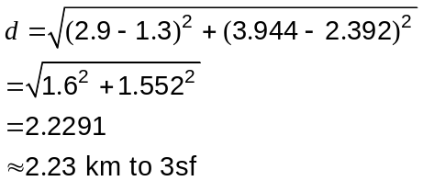


Question 15 (7 marks)
In a year group of 173 students, two subsets B and C exist. B is the set of students who study Biology and C is the set of students who study Chemistry.

n(B) 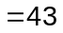 and there are 121 students who study neither Chemistry or Biology.

(a) Complete the two-way table below. (2 marks)

 |  |  | Total
 | 28 | 15 | 43
 | 9 | 121 | 130
Total | 37 | 136 | 173

-1 per error

(b) If one of the students is selected at random, determine the probability that the student studied either Chemistry or Biology but not both. (1 mark)

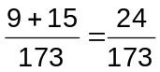

(c) Determine

(i) n(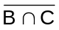) (1 mark)
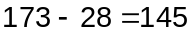

(ii) P(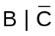) (1 mark)
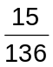

(d) Circle the smallest of the following three probabilities. Justify your answer. (2 marks)

 | P(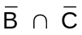) | P() | P(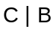)
 | 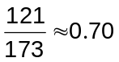 | 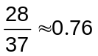 | 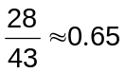

Working out 

Question 16 (6 marks)
In the diagram below (not drawn to scale) AE = DE = 16 cm, AD = 12 cm, CD = 11 cm and the size of angle DCB is 55°.
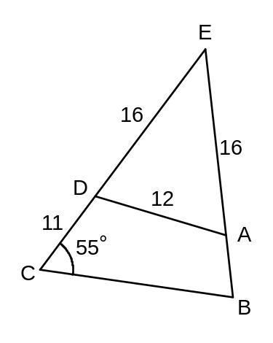

(a) Find the size of angle AED. (2 marks)
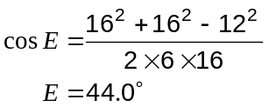


(b) Find the length AB. (4 marks)

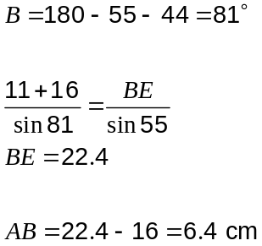


Question 17 (6 marks)
Two students were investigating ways to save some money on a weekly basis.

(a) Celia assumed that she already had $2.70 saved and planned to add 15c each week.

(i) How much would Celia have in total after 3 weeks? (1 mark)
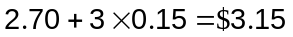

(ii) How many weeks would it take Celia to save a total of at least $4? (1 mark)
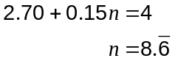

Take 9 weeks. 

(b) Ming started with just $2. He chose to add enough 5c coins each week so that his total would be 10% more than the previous weeks' total, when rounded to the nearest 5c.

(i) How much does Ming need to add in the first week? (1 mark)
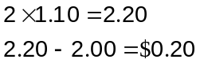

Add 20c. 

(ii) How much would Ming have in total after 3 weeks? (1 mark)
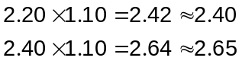

Total of $2.65. 

(c) Which student would be the first to save a total of at least $4 and how much more would they have than the other student at this time? (2 marks)

Ming. His total is $4.25 after 8 weeks but Celia takes 9 weeks to first exceed $4. 

(Mings totals are $2.00, $2.20, $2.40, $2.65, $2.90, $3.20, $3.50, $3.85, $4.25)

After 8 weeks Celia only has $3.90, so Ming has 35c more. 

